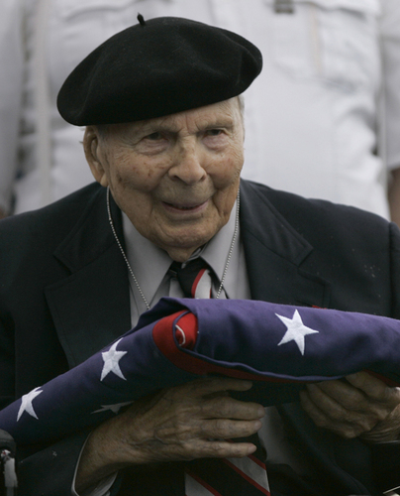

Frank Buckles

Frank Buckles, who died on February 27 aged 110,
was the last surviving American veteran of the First World War
and a living witness to the “American century”.
He didn’t seek the spotlight, but when Frank Buckles outlived every other American who’d served in World War I, he became what his biographer called “the humble patriot” and final torchbearer for the memory of that fading conflict. Buckles enlisted in World War I at 16 after lying about his age. He died Sunday on his farm in Charles Town, nearly a month after his 110th birthday. He had devoted the last years of his life to campaigning for greater recognition for his former comrades, prodding politicians to support a national memorial in Washington.
800m Run
22 Kettlebell Swings (70#M/50#W)
800m Run
22 Pull Ups
80m Run
22 Handstand Push Ups
800m Run
22 Thrusters (95#M/65#W)
800m Run
22 SumoDeadlift High Pull
800m Run

